2016 Australian Baseball Alumni
USA Baseball Tour Itinerary

Tour Dates - Wed 8/6/16 - Thu 16/6/16

If you enjoy baseball this is the trip for you. Come along on a trip of a lifetime
to the USA to see 5 Major League Baseball games in 5 stadiums in Los Angeles,
Phoenix, San Francisco and Oakland. You will meet ex Major League players and our Alumni contacts will offer us behind the scenes experiences .

Your hosts for the tour are Australian Major League Baseball player Glenn Williams and Baseball Dual Olympian Grant McDonald.

NOTE: Tour is for USA land component only. All Travellers will need to arrange own international flights from Australia to USA and return. For your international travel
arrangements we recommend Kellie Applefield from Hello World travel who's organising the
tour. Contact her on 07 3359 7990 or email appletravel@optusnet.com.au

08 June - Day - 1 - ANAHEIM

The tour starts in Anaheim at 2pm at the Red Lion Hotel in the Disneyland precinct. Please make
your own way to the Red Lion Hotel (transfers can be prearranged)

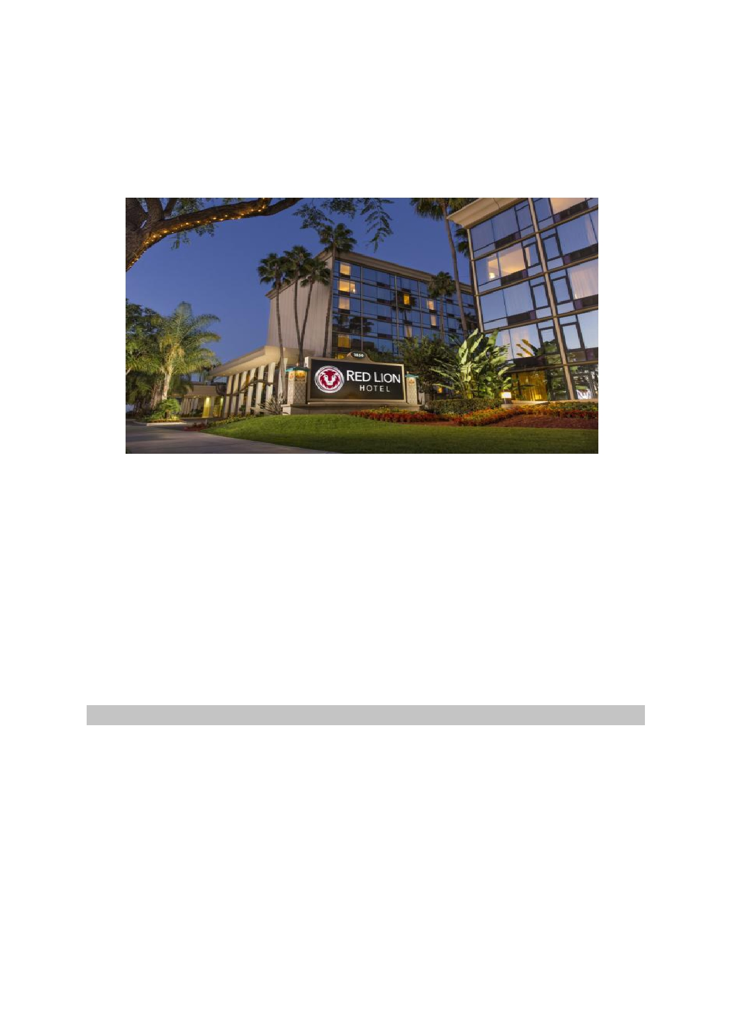
All tour members will meet up with the Hosts and get to know each other.
Evening - Baseball Game LA Dodgers vs Colorado Rockies 7.10pm.
You will be transferred from the Red Lion Hotel Anaheim to Dodger Stadium. On the completion of
the game you will return by coach to the Red Lion Hotel.

09 June - Day 2 - ANAHEIM - Dodger Stadium Tour

Today you will meet up with Aussie Major League player Trent Oeltjen and take a tour of Dodger Stadium.

The Dodger Stadium Tour provides fans the opportunity to see the ballpark in a very unique fashion. This behind-the-scenes tour lets fans visit some of the most restricted and non-public areas and view
the Stadium from a whole new perspective. As baseball's third-oldest stadium, Dodger Stadium remains one of the game's most beautiful and most historic venues.

Highlights of this 80-90 minute tour include:

• A trip down to the field at Dodger Stadium
• A visit into the Dodger Dugout
• An exclusive look at the Lexus Dugout Club, VIP restaurant and lounge located behind home
plate, home to the Dodger's World Series trophies, Most Valuable Player (MVP), Cy Young,
Silver Slugger and Rookie of the Year awards
• A walk through the Vin Scully Press Box, where the story of Dodger baseball is covered from
every angle
• And more surprises!

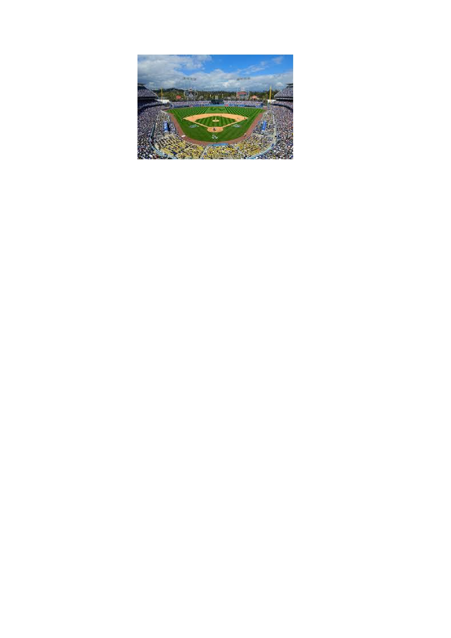
On completion of your tour you will return by coach to the Red Lion Hotel.

10 June - DAY 3 - ANAHEIM - Baseball Game Anaheim
Angels vs Cleveland Indians (time tba)

Most of the day is yours in Anaheim to do whatever you like.

You will make your own way to Angel Stadium to watch the Los Angeles Angels take on the Cleveland Indians.

Aussie Major Leaguer Ryan Rowland-Smith will catch up with the tour group during the stay in Anaheim.

11 June - Day 4 - ANAHIEM/PHOENIX - Baseball Game
Arizona Diamondbacks vs Miami Marlins 5.10pm

Today you will be transferred from the Red Lion Hotel to the Santa Ana Airport for your flight to Phoenix. Depart Santa Ana 10.40am Arrive Phoenix 11.50am Southwest Airlines Flight 454.

Once we arrive in Phoenix we'll check in at the Holiday Inn and Suites Ballpark in downtown Phoenix. Your accommodation here includes breakfast.

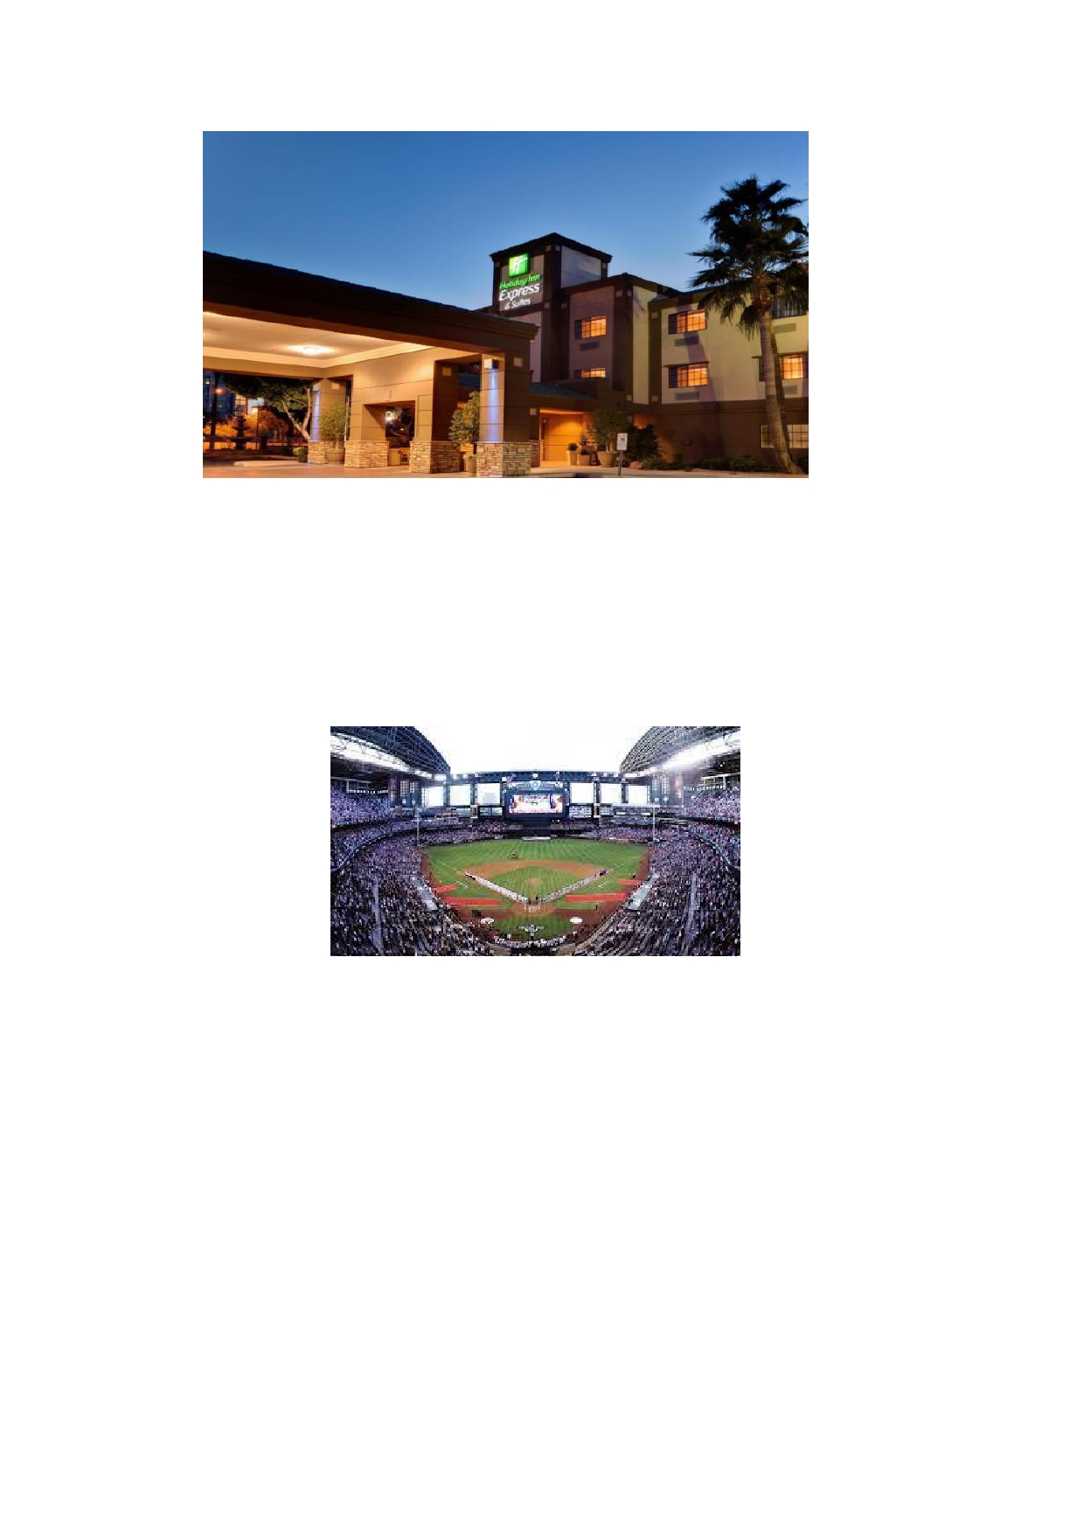
Next the tour group will make its way to Chase Field to watch BP and then the 5.10pm game
between the Arizona Diamondbacks vs Miami Marlins.

12 June - Day 5 - PHOENIX

Today the tour group will head out to the Arizona Diamondbacks Spring training facility for a private tour. We will meet up with Jeff Williams an Australian Major League Baseball player who had 3 years with the Los Angeles Dodgers and 7 years in the Japanese Big Leagues with
the Hanshin Tigers. He will talk to the group, reflect on his playing days, and share some tales from the dugout.

The rest of the day is free for you to see the sights.

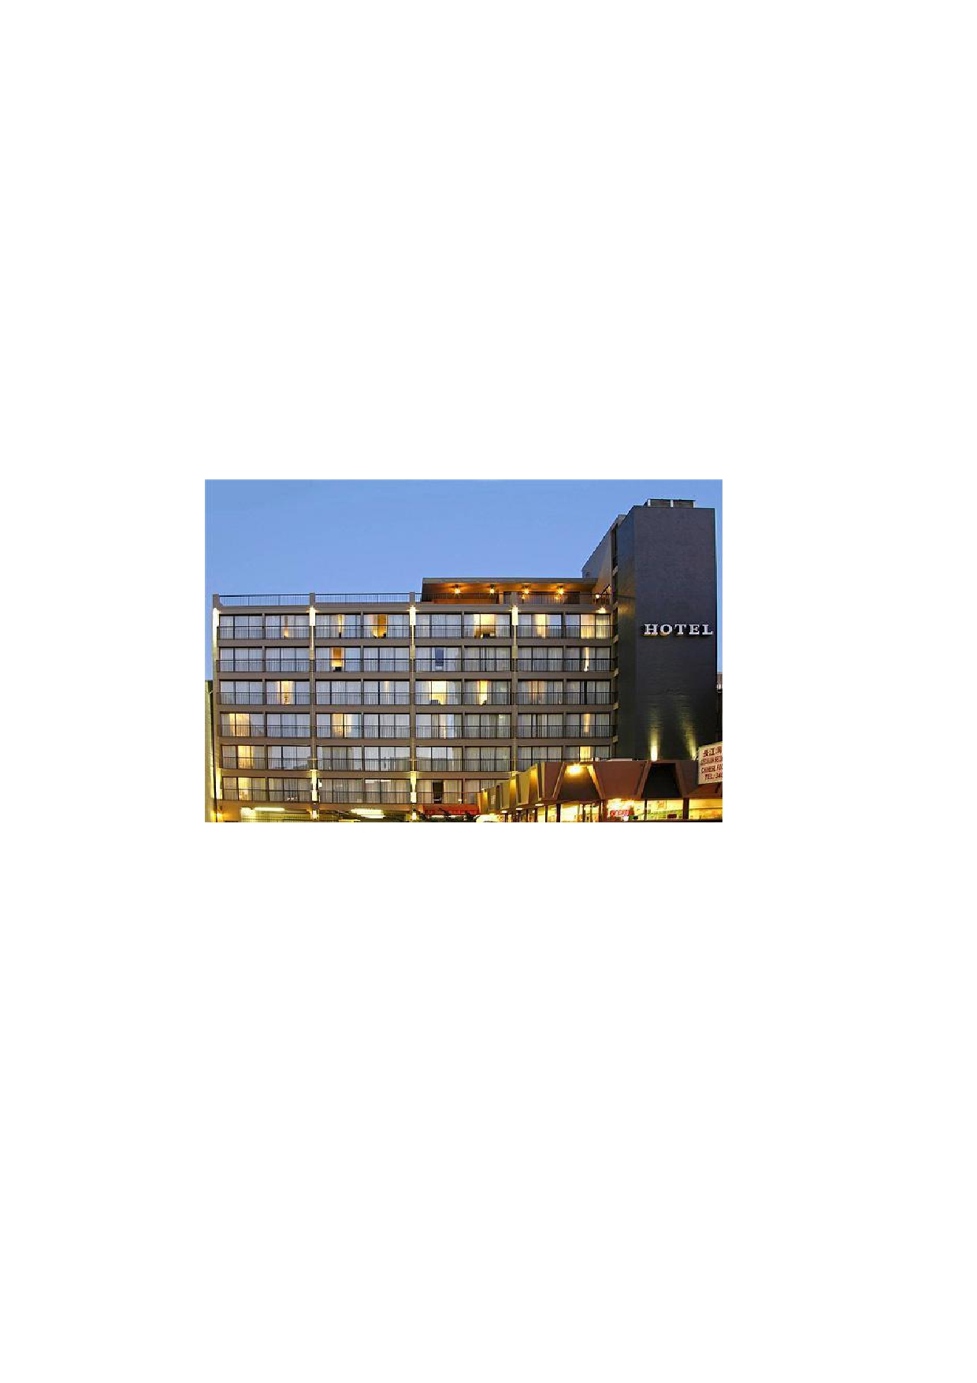
13 June - Day 6 - PHOENIX/SAN FRANCISCO

Today you will be transferred from the Holiday Inn Express and Suites Ballpark to a Phoenix
Sun Valley desert golf course for a round of golf. At the completion of golf you will be transferred to Phoenix Airport for your flight to San Francisco.

Your flight will depart Phoenix at 4.05pm and arrive San Francisco 6.05pm Southwest Airlines Flight 2108.

On arrival in San Francisco you will be transferred to your hotel.

Overnight - Cova Hotel including continental breakfast.

14 June - Day 7 - SAN FRANCISCO - Baseball Game San
Francisco Giants vs Milwaukee Brewers (time tba)

Today you will do a behind-the-scenes tour of AT&T Park where the tour group will visit
places only players and staff have access to. Today's tour includes access to the field
including the dugout. Visit the indoor batting cage and visitor's clubhouse before heading up into the stadium to the Press Box and Luxury suites.

At the conclusion of the tour you will stay back and watch the San Francisco Giants v Milwaukee Brewers.

15 June - Day 8 - SAN FRANCISCO - Baseball Game Oakland
Athletics vs Texas Rangers 7.10pm

Today you can explore San Francisco at your leisure.

At 5pm you will be transferred from the Cova Hotel to the Oakland Alameda County
Coliseum to watch the Oakland Athletics v Texas Rangers. On completion of the game a return transfer will take you back to the Cova Hotel.

16 June - Day 9 - SAN FRANCISCO - Tour Concludes

The Australian Baseball Alumni tour concludes today, hopefully leaving you lasting
memories and unforgettable experiences of the previous 9 days. Tour members leave the tour today in San Francisco and are responsible for making their own arrangements from this point.

TOTAL TOUR PRICE is $3400.
For further information and to register your interest and a spot on the tour please email
events@abpaa.com. A deposit of $500 will secure your spot in this once in a lifetime baseball tour.

Tour Package Includes: *

*Australian Baseball Alumni Tour Cap.

*Anaheim - 3 nights accommodation at the Red Lion Hotel
*Tickets to 5 MLB baseball games and 2 Stadium Tours
*Return hotel/field transfers by Coach (LA Dodgers Game)
*Return hotel/field transfers by Coach (Dodger Stadium Tour)
*One way airfare Anaheim to Phoenix flying Southwest Airlines
*Arrival Transfer from Phoenix Airport to Diamondback Spring Training Facility and then to Holiday
Inn and Suites Downtown
*Phoenix - 2 nights accommodation at the Holiday Inn and Suites Downtown Ballpark in a standard
room including breakfast daily
*Departure Transfer from Holiday Inn and Suites Downtown to Phoenix Golf Course
*Departure Transfer from Phoenix Golf Course to Phoenix Airport
*One way airfare Phoenix to San Francisco flying Southwest airlines
*San Francisco -3 nights accommodation at the Cova Hotel in standard rooms including deluxe
continental breakfast
*Arrival Transfer airport to hotel by coach in San Francisco
*Return airport/field transfers by Coach (Oakland Athletics game)
*Return airport/field transfers by Coach (San Francisco Giants game)

Important information to note:

• Tour starts at Red Lion Hotel Anaheim in USA on 8/6/16 at 2pm.
• All tour members must arrange own return international flights from Australia to USA.
• Stadium tours subject to availability.
• Pricing subject to currency fluctuations of USD at time of booking.
• Prices for the Southwest airlines airfares are based on March 2016, as June 2016
pricing has not been released at this stage, therefore pricing may change due to rates
at time of booking
• All Airfares and prices are subject to availability at time of booking. 2. All airfares and
prices are subject to change without notice and cannot be guaranteed until full
payment has been received. 3. Prices quoted are current at time of quotation. We
cannot guarantee a quoted price until such time as the travel arrangements are
confirmed in writing. Once travel arrangements are confirmed and deposit paid, prices are still subject to change until full payment is received. 4. All quotations are based on cash or cheque payment only. Credit card payment is permitted at an additional fee. 5.
Once deposit and/or final payment is received, cancellation and/or amendment fees
will apply. 6. Our schedule of fees is on display in our office and is also available on
request. 7. Travel operators such as airlines, tour operators, hotels and car rental
companies may also levy amendment and cancellation fees. It is important that you
understand these fees and we can assist you with any questions you may have. 8. GST:
prices and costs quoted include GST (where GST applies) unless expressly stated otherwise.

• *Any amendments to bookings will incur a $50 per person amendment fee.
Cancellation fees will apply.
• All tour members responsible for and must have appropriate travel insurance before
tour.

• Once travel arrangements are confirmed and deposit paid, prices are still subject to
change until full payment is received

Cheers

Grant McDonald

Australian Alumni Committee Member

